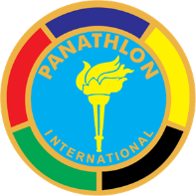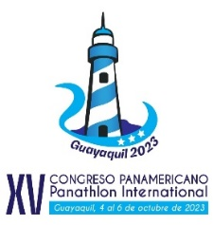
XV PAN AMERICAN CONGRESS PANATHLON
Guayaquil – Ecuador
October 4 to 6, 2023

REGISTRATION FORM

I.- Participant data

Name and surname

Home Club
Function it performs

Cell phone E-mail

Flights/dates of arrival and departure
/
/

II.- Passenger data

Name and surname

III.-Daily accommodation rates (Oro Verde Hotel)
Single US$ 85.00

Double US$ 90.00 (US$ 45.00 per pax)

Double Suite US$ 105.00 (US$ 52.50 per pax)

Note: All rates include ecuadorian taxes (22 %), buffet breakfast and 24 hours medical assistance service in Hotel. (Check in: 15h00 y Check out: 12h00)

IV.- Registration / XV Pan American Congress

Participant US$ 140.00 Include: transfer from and to airport, internal mobilization, welcome cocktail, work materials, coffee break, working lunches, gala dinner, farewell dinner, music concert, city tour, certificate and souvenirs.

Passenger US$ 90.00 Include: transfer from and to airport, internal mobilization, welcome cocktail, working lunches, gala dinners, farewell dinner, music concert, city tour and souvenirs.
XV PAN AMERICAN CONGRESS PANATHLON
Guayaquil – Ecuador

ACTIVITY PROGRAM

Wednesday 04
12h00 – 15h00 Accreditation of participants (Oro Verde Hotel)
17h30 – 18h00 Visit to authorities of Guayaquil
19h30 – 22h00 Welcome Cocktail/Music Concert (Teather Center of Art)

Thursday 05
07h00 – 08h30 Breakfast (Oro Verde Hotel)
07h30 – 09h00 Accreditation of participants (Oro Verde Hotel)
09h30 – 13h00 Opening Program (Oro Verde Hotel)
13h30 – 14h30 Work Lunch (Oro Verde Hotel)
15h00 – 16h40 Conferences (Oro Verde Hotel)
16h40 – 17h00 Coffee break
17h00 – 18h15 Conferences (Oro Verde Hotel)
20h00 – 21h15 Gala Dinner (Club de La Union)

Friday 06
07h00 – 08h15 Breakfast (Oro Verde Hotel)
08h30 – 11h00 Conferenes (Oro Verde Hotel)
11h10 – 11h30 Coffee break
11h30 – 13h30 Conferences (Oro Verde Hotel)
13h30 – 13h45 Guayaquil Declaration and Closing Ceremony
14h00 – 15h00 Working Lunch (Oro Verde Hotel)
15h30 – 16h00 Sports Memorability Exhibition
16h00 – 18h00 City tour
20h00 – 22h00 Farewell Diner (Plaza Lagos)

Saturday 07
07h00 – 08h30 Breakfast (Oro Verde Hotel)
08h00 – 12h00 Return of participants

